**SmartShop AI E-Commerce Platform - Screenshots**

* Frontend - React/Next.js Interface  
  Modern e-commerce storefront built with React and Next.js. Fast loading, mobile-friendly design with shopping cart and product search.

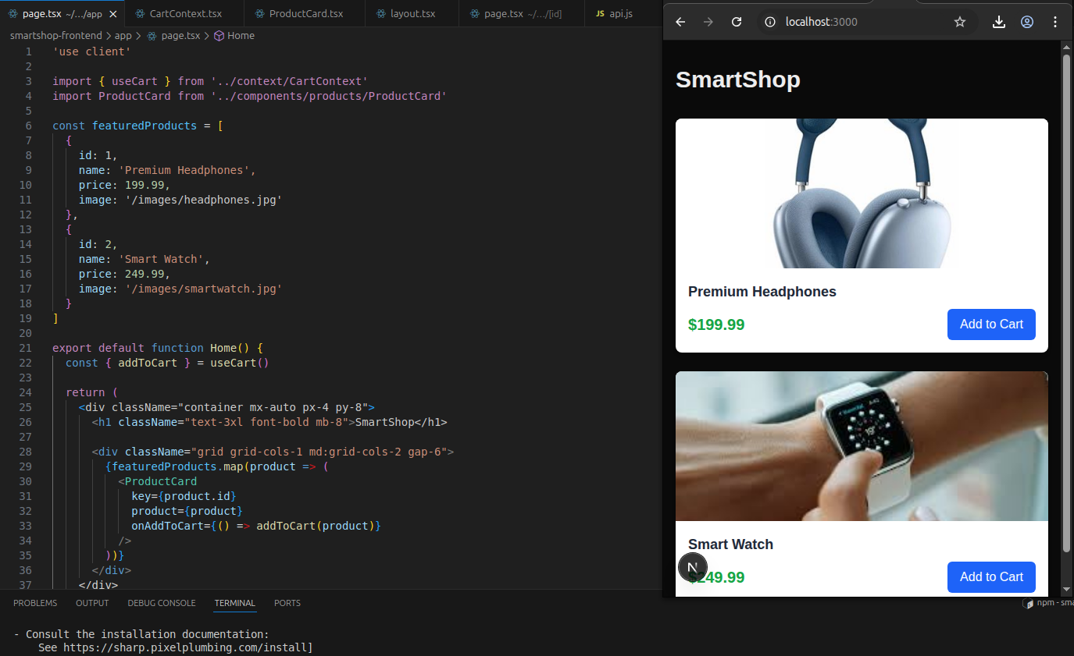

* S3 Static Page   
  Website hosted on AWS S3 as a static page ready to be integrated with CloudFront for lightning-fast global delivery.

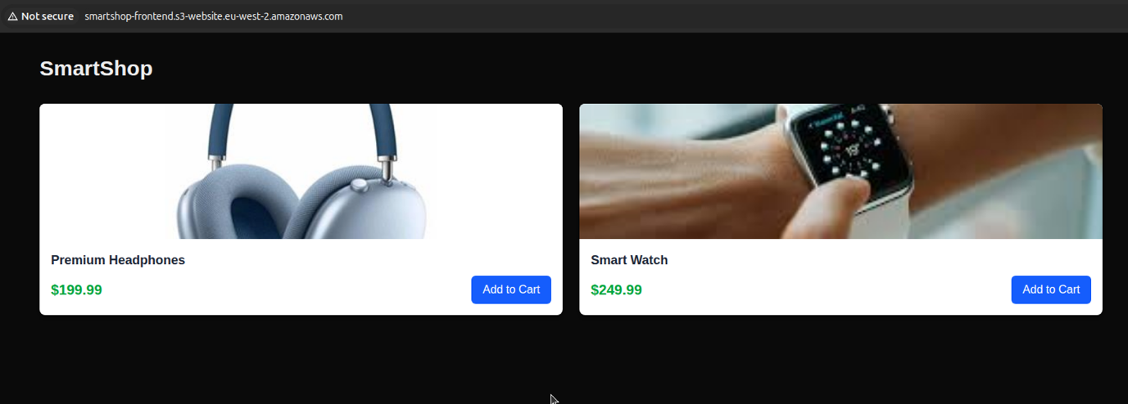

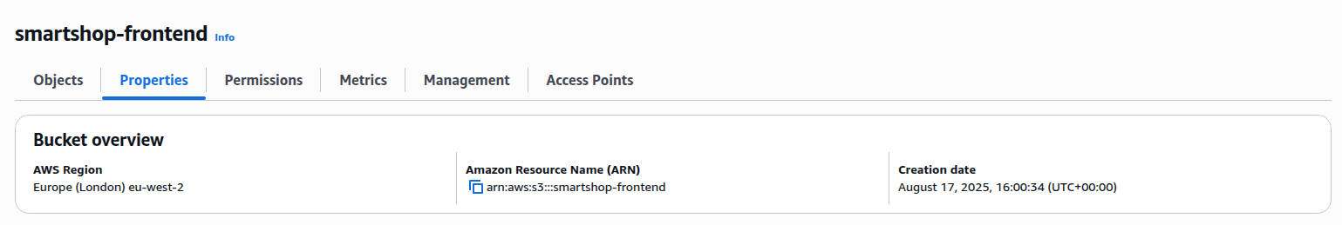

* S3 + CloudFront Distribution  
  Website hosted on AWS S3 with CloudFront CDN for lightning-fast global delivery. No servers needed - just upload and go live worldwide.

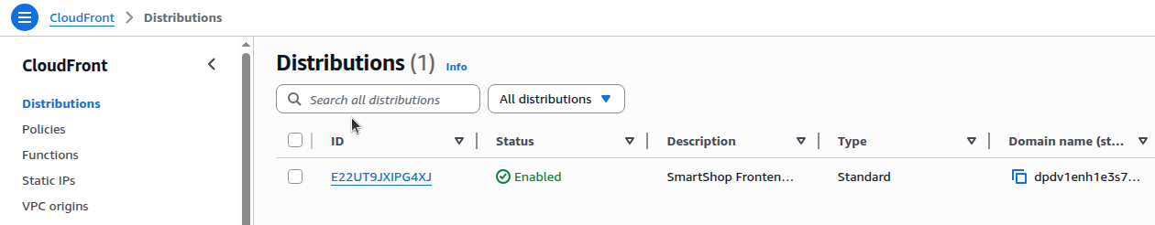



* Docker Containers  
  All backend services run in Docker containers. Each service is isolated and can be updated independently without breaking others.

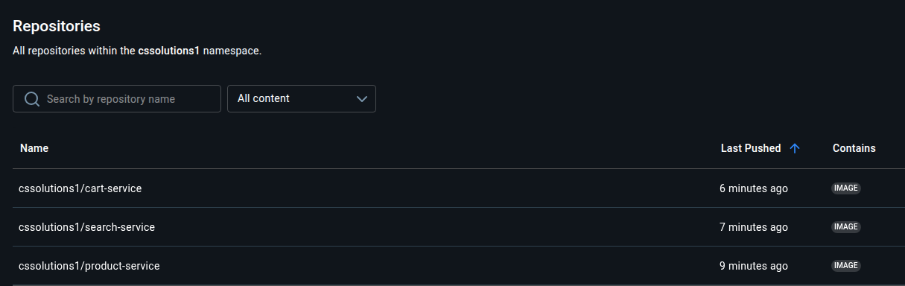

* Kubernetes Dashboard  
  Local Kubernetes cluster managing all microservices. Same setup large companies implement - auto-scaling, health checks, and zero-downtime updates.

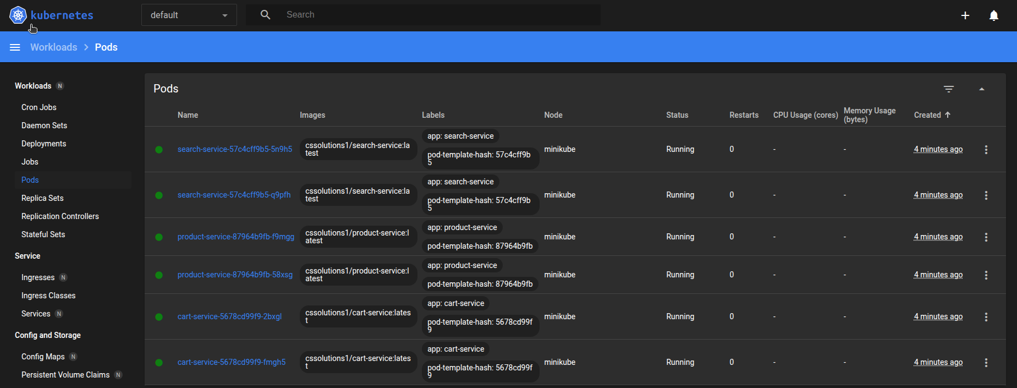

* Microservices Architecture  
  Backend split into small, focused services: Product API, Search Engine, Recommendations, and Gateway. Scale each part separately.
* Production Scaling  
  Easy path from laptop to enterprise scale. One-click deploy to AWS EKS handles millions of users automatically.

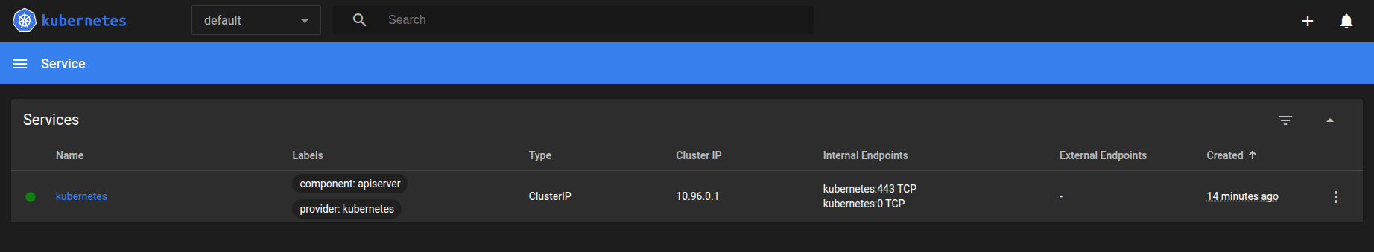

* PostgreSQL Database  
  Rock-solid PostgreSQL database storing all product data, orders, and user info. Built-in admin panel for easy data management.

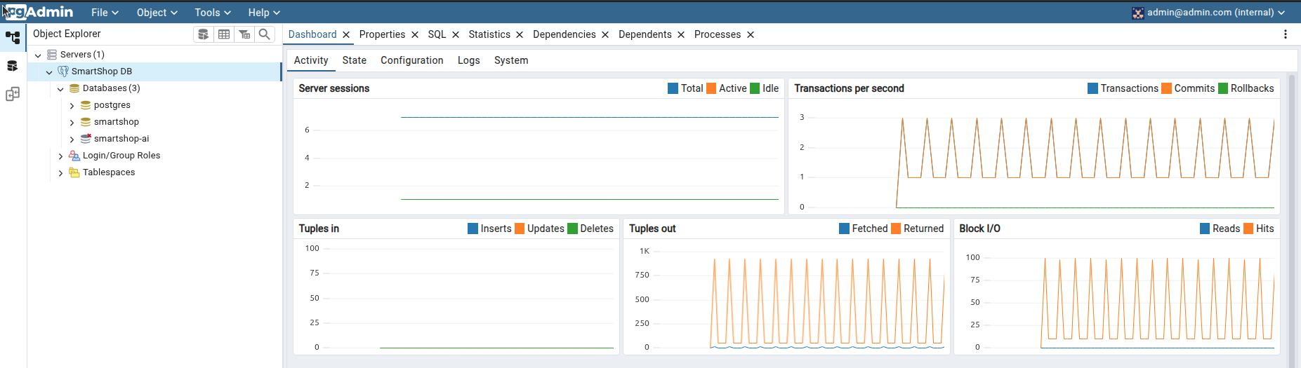

* SageMaker AI Recommendations  
  Amazon SageMaker powers smart product recommendations. Machine learning suggests products users actually want to buy.
* CloudWatch Monitoring  
  Real-time monitoring dashboard tracking website performance, errors, and user activity. Get alerts when something goes wrong.

Full Architecture pictured below:

